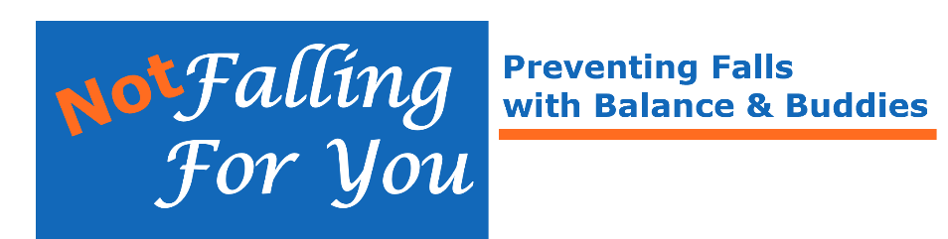

Edmonton Area Classes for Fall 2024
NOT Falling for You is offered by community organizations with support from Alberta Health Services and the Injury Prevention Centre, Finding Balance Program.
Visit findingbalancealberta.ca/nffy/ for more information.
Unless otherwise stated, contact injury.preventionedmonton@ahs.ca
or phone: 780-735-3004 to register, join waiting list, or for more information.
Beverly Active Seniors Society
Thursdays, 10:30 am – 11:45 am
Starts September 12, 2024
Beverly Heights Community Hall, 4209 111 Ave NW, Edmonton

City of Fort Saskatchewan (Full)
Fridays, 11:00 am – 12: 00 pm
September 13 – November 29, 2024
City Hall, 10005 102 St, Room 1, Fort Saskatchewan, AB
Register at fortsask.ca/GoLeisure (course code 17244)
or Phone: 780-992-6400

EPL Capilano Library Branch
Mondays, 10:30 am – 11:45 am
September 9- October 28, 2024 and November 4-December 16, 2024
Capilano Library, 9915 -67 St NW, Edmonton
Register at: epl.ca Search Events: NOT Falling for You

Parkallen Community League (waiting list only)
Tuesdays, 9:30 am – 10:45 am
September 17-November 26, 2024
Parkallen Community Hall, 6510 111 St NW, Edmonton

Page 2

Robertson-Wesley United Church
Thursdays, 10:00 am – 11:15 am
September 19 – December 12, 2024
10209 123 St NW, Edmonton

SEESA (South East Edmonton Seniors Association) (Full)
Fridays, 1:15 – 2:30 pm
September 13-October 25, 2024; and November 1- December 20, 2024
SEESA, 9350 82 Street NW, Edmonton
Register at: info@seesa.ca or Phone: 780-468-1985

ICAN Seniors Association
*Various Days, 10:15-11:30 am
September 3, 5, 10, 17, 24 and October 10, 15, 17, 22, 29, 2024
Holy Spirit Lutheran Church, 11223 51 Ave NW, Edmonton
This class is presented in Mandarin and Cantonese.
Contact Charis Wong at charis@weseniors.ca
or Phone 780-716-2816 ext. 226 to register or for more information.

