Zoomers in Balance Online Class Schedule
Summer 2024
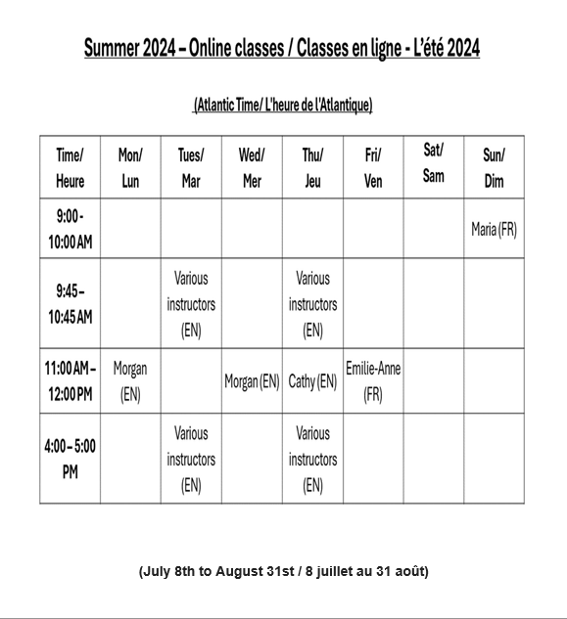
Atlantic Time is 3 hours ahead of Mountain Time. For example, classes starting at 11 am Atlantic time will begin at 8 am Mountain Time.

